ASSIGNMENT 1A

#include<iostream>

#include<stdlib.h>

#include<queue>

using namespace std;

class node

{

public:

node *left, *right;

int data;

};

class Breadthfs

{

public:

node *insert(node *, int);

void bfs(node *);

};

node* Breadthfs::insert(node* root, int data)

{

if (!root) {

root = new node;

root->left = NULL;

root->right = NULL;

root->data = data;

return root;

}

queue<node*> q;

q.push(root);

while (!q.empty()) {

node* temp = q.front();

q.pop();

if (temp->left == NULL) {

temp->left = new node;

temp->left->left = NULL;

temp->left->right = NULL;

temp->left->data = data;

return root;

}

else {

q.push(temp->left);

} if (temp->right == NULL) {

temp->right = new node;

temp->right->left = NULL;

temp->right->right = NULL;

temp->right->data = data;

return root;

}

else {

q.push(temp->right);

}

}

// add a default return statement

return root;

}

void printTreeHelper(node* root, int space)

{ if (root == NULL)

return;

space += 10;

printTreeHelper(root->right, space);

cout<<endl;

for (int i = 10; i < space; i++)

cout<<" ";

cout<<root->data<<"\n";

printTreeHelper(root->left, space);

}

void printTree(node* root)

{

printTreeHelper(root, 0);

}

Void Breadthfs::bfs(node *head)

{queue<node*> q;

q.push(head);

int qSize;

while (!q.empty())

{

qSize = q.size();

#pragma omp parallel for

for (int i = 0; i < qSize; i++)

{

node* currNode;

#pragma omp critical

{

currNode = q.front();

q.pop();

cout<<"\t"<<currNode->data;

}

#pragma omp critical

{

if(currNode->left)

q.push(currNode->left);

if(currNode->right)

q.push(currNode->right);

}

}

}

}

int main()

{

node *root=NULL;

int data;

char ans;

do

{ cout<<"\n enter data=>";

cin>>data;

root=Breadthfs().insert(root,data);

cout<<"do you want insert one more node?";

cin>>ans;

} while(ans=='y'||ans=='Y');

cout<<"Tree:\n";

printTree(root);

cout<<"\nBreadth First Search:";

Breadthfs().bfs(root);

cout<<"\n";

return 0;

}

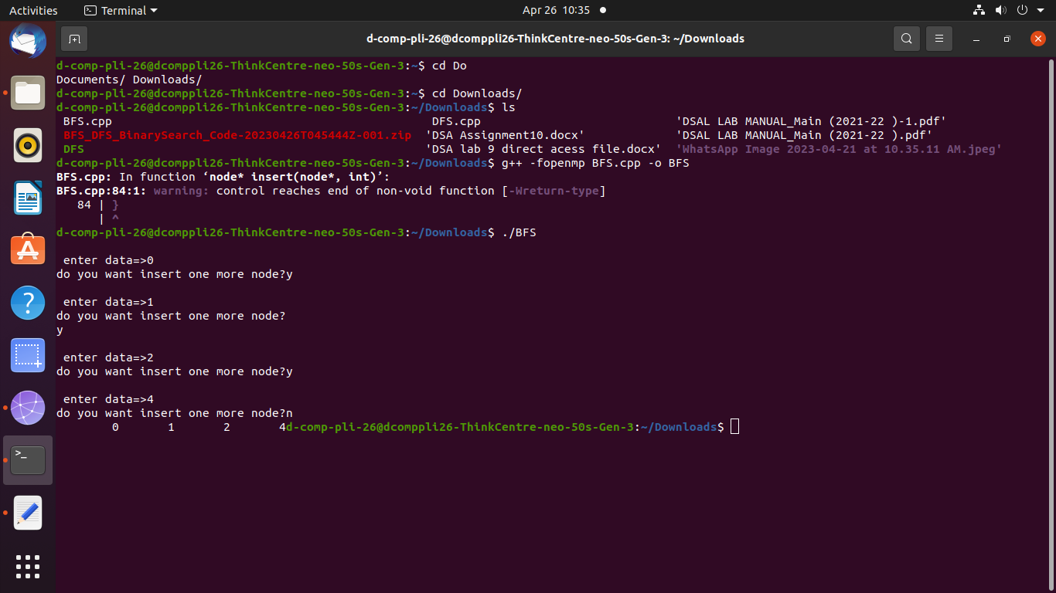

ASSIGNMENT 1B

#include <iostream>

#include <vector>

#include <stack>

#include <omp.h>

using namespace std;

const int MAX = 100000;

vector<int> graph[MAX];

bool visited[MAX];

void dfs(int node) {

stack<int> s;

s.push(node);

while (!s.empty()) {

int curr_node = s.top();

if (!visited[curr_node]) {

visited[curr_node] = true;

s.pop();

cout << curr_node << " ";

#pragma omp parallel for

for (int i = 0; i < graph[curr_node].size(); i++) {

int adj_node = graph[curr_node][i];

if (!visited[adj_node]) {

s.push(adj_node);

}

}

}

}

}

int main() {

int n, m, start_node;

cout << "Enter no. of nodes, no. of edges, and starting node of graph:\n";

cin >> n >> m >> start_node;

cout << "Enter pairs of nodes and edges:\n";

for (int i = 0; i < m; i++) {

int u, v;

cin >> u >> v;

graph[u].push_back(v);

graph[v].push_back(u);

}

#pragma omp parallel for

for (int i = 0; i < n; i++) {

visited[i] = false;

}

dfs(start_node);

cout << endl; // add new line after output

return 0;

}

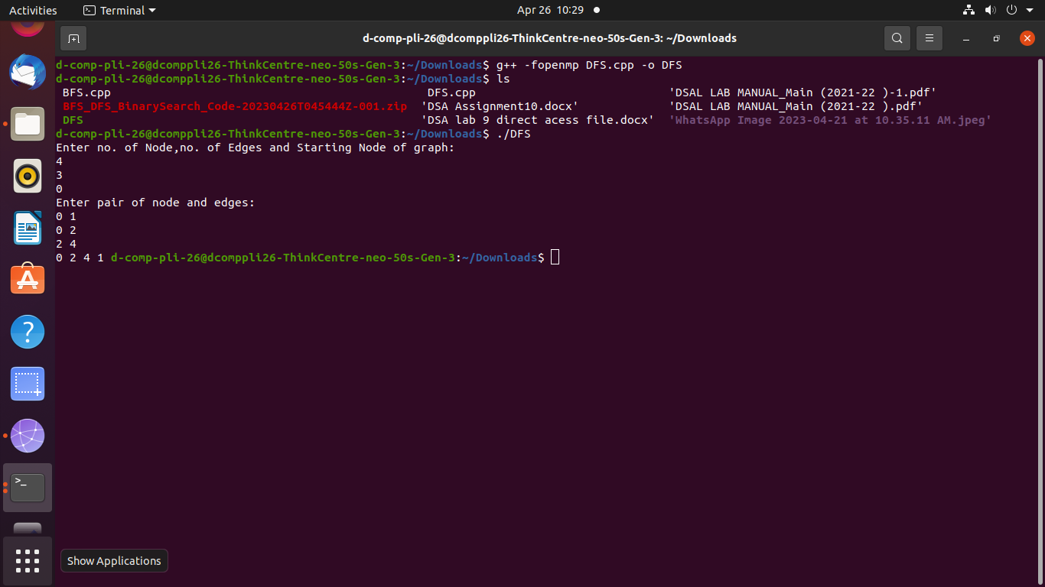

ASSIGNMENT 2A

#include<iostream>

#include<stdlib.h>

#include<queue>

using namespace std;

class node

{

public:

node *left, *right;

int data;

};

class Breadthfs

{

public:

node *insert(node *, int);

void bfs(node *);

};

node* Breadthfs::insert(node* root, int data)

{

if (!root) {

root = new node;

root->left = NULL;

root->right = NULL;

root->data = data;

return root;

}

queue<node*> q;

q.push(root);

while (!q.empty()) {

node* temp = q.front();

q.pop();

if (temp->left == NULL) {

temp->left = new node;

temp->left->left = NULL;

temp->left->right = NULL;

temp->left->data = data;

return root;

}

else {

q.push(temp->left);

}

if (temp->right == NULL) {

temp->right = new node;

temp->right->left = NULL;

temp->right->right = NULL;

temp->right->data = data;

return root;

}

else {

q.push(temp->right);

}

}

// add a default return statement

return root;

}

void printTreeHelper(node* root, int space)

{

if (root == NULL)

return;

space += 10;

printTreeHelper(root->right, space);

cout<<endl;

for (int i = 10; i < space; i++)

cout<<" ";

cout<<root->data<<"\n";

printTreeHelper(root->left, space);

}

void printTree(node* root)

{

printTreeHelper(root, 0);

}

void Breadthfs::bfs(node *head)

{

queue<node*> q;

q.push(head);

int qSize;

while (!q.empty())

{

qSize = q.size();

#pragma omp parallel for

for (int i = 0; i < qSize; i++)

{

node* currNode;

#pragma omp critical

{

currNode = q.front();

q.pop();

cout<<"\t"<<currNode->data;

}

#pragma omp critical

{

if(currNode->left)

q.push(currNode->left);

if(currNode->right)

q.push(currNode->right);

}

}

}

}

int main()

{

node *root=NULL;

int data;

char ans;

do

{

cout<<"\n enter data=>";

cin>>data;

root=Breadthfs().insert(root,data);

cout<<"do you want insert one more node?";

cin>>ans;

} while(ans=='y'||ans=='Y');

cout<<"Tree:\n";

printTree(root);

cout<<"\nBreadth First Search:";

Breadthfs().bfs(root);

cout<<"\n";

return 0;

}

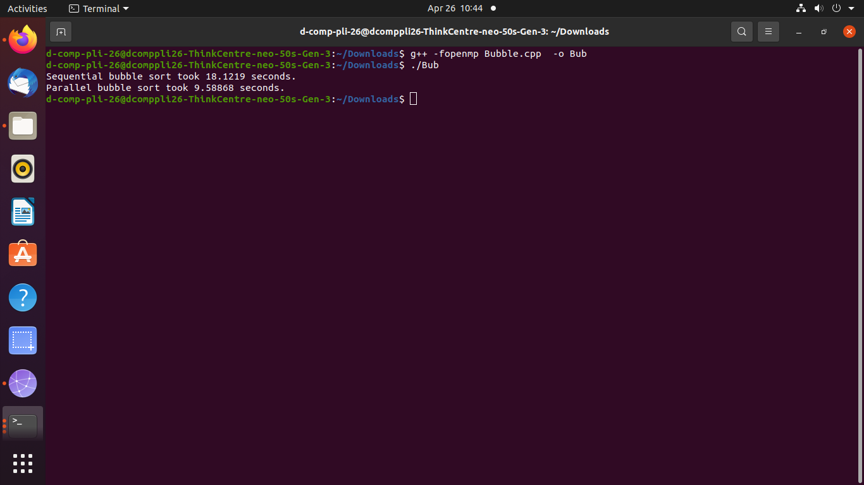

ASSIGNMENT 2B

#include <iostream>

#include <vector>

#include <stack>

#include <omp.h>

using namespace std;

const int MAX = 100000;

vector<int> graph[MAX];

bool visited[MAX];

void dfs(int node) {

stack<int> s;

s.push(node);

while (!s.empty()) {

int curr_node = s.top();

if (!visited[curr_node]) {

visited[curr_node] = true;

s.pop();

cout << curr_node << " ";

#pragma omp parallel for

for (int i = 0; i < graph[curr_node].size(); i++) {

int adj_node = graph[curr_node][i];

if (!visited[adj_node]) {

s.push(adj_node);

}

}

}

}

}

int main() {

int n, m, start_node;

cout << "Enter no. of nodes, no. of edges, and starting node of graph:\n";

cin >> n >> m >> start_node;

cout << "Enter pairs of nodes and edges:\n";

for (int i = 0; i < m; i++) {

int u, v;

cin >> u >> v;

graph[u].push_back(v);

graph[v].push_back(u);

}

#pragma omp parallel for

for (int i = 0; i < n; i++) {

visited[i] = false;

}

dfs(start_node);

cout << endl; // add new line after output

return 0;

}

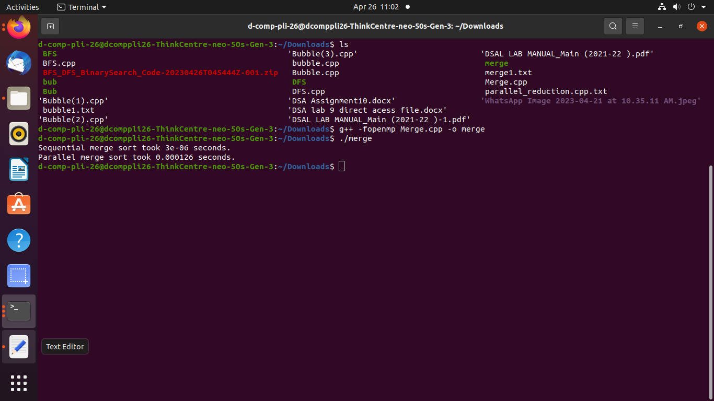

ASSIGNMENT 3

#include <iostream>

#include <vector>

#include <omp.h>

#include <climits>

using namespace std;

int min_reduction(vector<int>& arr) {

int min_value = INT_MAX;

#pragma omp parallel for reduction(min: min_value)

for (int i = 0; i < arr.size(); i++) {

if (arr[i] < min_value) {

min_value = arr[i];

}

}

return min_value;

}

int max_reduction(vector<int>& arr) {

int max_value = INT_MIN;

#pragma omp parallel for reduction(max: max_value)

for (int i = 0; i < arr.size(); i++) {

if (arr[i] > max_value) {

max_value = arr[i];

}

}

return max_value;

}

int sum_reduction(vector<int>& arr) {

int sum = 0;

#pragma omp parallel for reduction(+: sum)

for (int i = 0; i < arr.size(); i++) {

sum += arr[i];}

return sum;

}

double average_reduction(vector<int>& arr) {

int sum = 0;

#pragma omp parallel for reduction(+: sum)

for (int i = 0; i < arr.size(); i++) {

sum += arr[i];

}

return (double)sum / arr.size();

}

int main() {

vector<int> arr;

arr.push_back(5);

arr.push_back(2);

arr.push_back(9);

arr.push_back(1);

arr.push_back(7);

arr.push_back(6);

arr.push_back(8);

arr.push_back(3);

arr.push_back(4);

int min_value = min_reduction(arr);

int max_value = max_reduction(arr);

int sum = sum_reduction(arr);

double average = average_reduction(arr);

cout << "Minimum value: " << min_value << endl;

cout << "Maximum value: " << max_value << endl;

cout << "Sum: " << sum << endl;

cout << "Average: " << average << endl;

}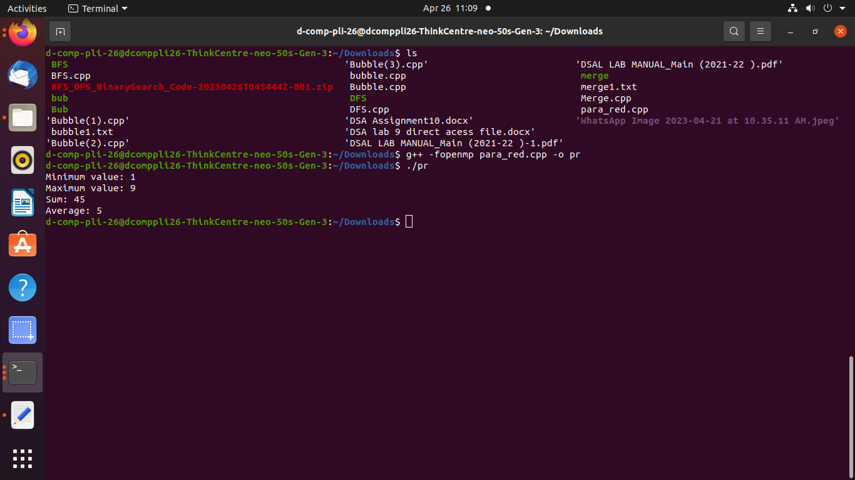

ASSIGNMENT 4A

#include <iostream>

#include <cuda_runtime.h>

__global__ void addVectors(int* A, int* B, int* C, int n) {

int i = blockIdx.x * blockDim.x + threadIdx.x;

if (i < n) {

C[i] = A[i] + B[i];

}

}

int main() {

int n = 1000000;

int* A, * B, * C;

int size = n * sizeof(int);

// Allocate memory on the host

cudaMallocHost(&A, size);

cudaMallocHost(&B, size);

cudaMallocHost(&C, size);

// Initialize the vectors

for (int i = 0; i < n; i++) {

A[i] = i;

B[i] = i * 2

// Allocate memory on the device

int* dev_A, * dev_B, * dev_C;

cudaMalloc(&dev_A, size);

cudaMalloc(&dev_B, size);

cudaMalloc(&dev_C, size);

// Copy data from host to device

cudaMemcpy(dev_A, A, size,

cudaMemcpyHostToDevice);

cudaMemcpy(dev_B, B, size,

cudaMemcpyHostToDevice);

// Launch the kernel

int blockSize = 256;

int numBlocks = (n + blockSize

- 1) / blockSize

// Copy data from device to host

cudaMemcpy(C, dev_C, size, cudaMemcpyDeviceToHost);

// Print the results

for (int i = 0; i < 10; i++) {

cout << C[i] << " ";

}

cout << endl;

// Free memory

cudaFree(dev_A);

cudaFree(dev_B);

cudaFree(dev_C);

cudaFreeHost(A);

cudaFreeHost(B);

cudaFreeHost(C);

return 0;

ASSIGNMENT 4B

#include <cuda_runtime.h>

#include <iostream>

__global__ void matmul(int* A, int* B, int* C, int N) {

int Row = blockIdx.y*blockDim.y+threadIdx.y;

int Col = blockIdx.x*blockDim.x+threadIdx.x;

if (Row < N && Col < N) {

int Pvalue = 0;

for (int k = 0; k < N; k++) {

Pvalue += A[Row*N+k] * B[k*N+Col];

}

C[Row*N+Col] = Pvalue;

}

}

int main() {

int N = 512;

int size = N * N * sizeof(int);

int* A, * B, * C;

int* dev_A, * dev_B, * dev_C;

cudaMallocHost(&A, size);

cudaMallocHost(&B, size);

cudaMallocHost(&C, size);

63

cudaMalloc(&dev_A, size);

cudaMalloc(&dev_B, size);

cudaMalloc(&dev_C, size);

// Initialize matrices A and B

for (int i = 0; i < N; i++) {

for (int j = 0; j < N; j++) {

A[i*N+j] = i*N+j;

B[i*N+j] = j*N+i;

}

}

cudaMemcpy(dev_A, A, size,

cudaMemcpyHostToDevice);

cudaMemcpy(dev_B, B, size,

cudaMemcpyHostToDevice);

dim3 dimBlock(16, 16);

dim3 dimGrid(N/dimBlock.x, N/dimBlock.y);

matmul<<<dimGrid, dimBlock>>>(dev_A, dev_B,

dev_C, N);

cudaMemcpy(C, dev_C

64

// Print the result

for (int i = 0; i < 10; i++) {

for (int j = 0; j < 10; j++) {

std::cout << C[i*N+j] << " ";

}

std::cout << std::endl;

}

// Free memory

cudaFree(dev_A);

cudaFree(dev_B);

cudaFree(dev_C);

cudaFreeHost(A);

cudaFreeHost(B);

cudaFreeHost(C);

return 0

MINI PROJECT HPC

#include <iostream>

#include <algorithm>

#include <mpi.h>

using namespace std;

// Function to partition the array

int partition(int arr[], int low, int high) {

int pivot = arr[high];

int i = (low - 1);

for (int j = low; j <= high- 1; j++) {

if (arr[j] <= pivot) {

i++;

swap(arr[i], arr[j]);

}

}

swap(arr[i + 1], arr[high]);

return (i + 1);

}

// Function to perform quicksort on the partition

void quicksort(int arr[], int low, int high) {

if (low < high) {

int pivot = partition(arr, low, high);

quicksort(arr, low, pivot - 1);

quicksort(arr, pivot + 1, high);

}

}

int main(int argc, char *argv[]) {

int rank, size;

MPI_Init(&argc, &argv);

MPI_Comm_size(MPI_COMM_WORLD, &size);

MPI_Comm_rank(MPI_COMM_WORLD, &rank);

int n = 100;

int* arr = new int[n];

int* recvbuf = new int[n];

int* sendbuf = new int[n];

// Fill the array with random values

if (rank == 0) {

for (int i = 0; i < n; i++) {

arr[i] = rand() % 100;

}

}

// Divide the array into equal-sized partitions for each process

int sub_arr_size = n / size;

int* sub_arr = new int[sub_arr_size];

MPI_Scatter(arr, sub_arr_size, MPI_INT, sub_arr, sub_arr_size, MPI_INT, 0, MPI_COMM_WORLD);

// Sort the partition using quicksort

quicksort(sub_arr, 0, sub_arr_size - 1);

// Gather the sorted partitions from each process

MPI_Gather(sub_arr, sub_arr_size, MPI_INT, recvbuf, sub_arr_size, MPI_INT, 0, MPI_COMM_WORLD);

if (rank == 0) {

// Print the sorted array

for (int i = 0; i < n; i++) {

cout << recvbuf[i] << " ";

}

cout << endl;

// Measure the execution time of the parallel quicksort algorithm

double start_time = MPI_Wtime();

// Perform the above steps again

double end_time = MPI_Wtime();

double parallel_execution_time = end_time - start_time;

// Measure the execution time of the sequential quicksort algorithm

start_time = MPI_Wtime();

quicksort(arr, 0, n - 1);

end_time = MPI_Wtime();

double sequential_execution_time = end_time - start_time;

// Calculate speedup and efficiency

double speedup = sequential_execution_time / parallel_execution_time;

double efficiency = speedup / size;

cout << "Sequential execution time: " << sequential_execution_time << endl;

cout << "Parallel execution time: " << parallel_execution_time << endl;

cout << "Speedup: " << speedup << endl;

cout << "Efficiency: " << efficiency << endl;

}

MPI_Finalize();

return 0;

}

